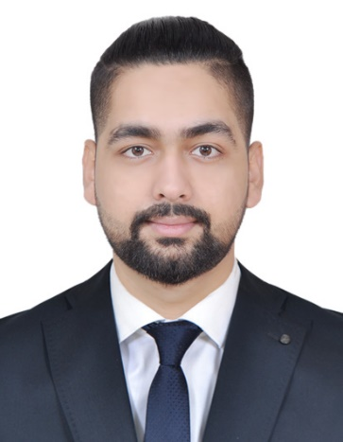

**SAURAB DEEP SEDHAI**

Al Nahda 1, Sharjah, UAE

E: [sedhaideep@gmail.com](mailto:sedhaideep@gmail.com)

M: +971 50 207 4113

**Professional Summary**

To be able to join an organization whereby I can contribute, practice and enhance my expertise as, Sales, Marketing, Customer Services and Office Administration.  I am hardworking person, fast-learner, an organized person and love to deal with different people. I am fully oriented in customer service and possess a good communication skill.

**Employment History**

**The Hideout**, Marina Byblos Hotel, Dubai Marina, UAE

Position : Administrative Assistant cum Accounts Supervisor

Industry : Food and Beverage

Duration : November 2018 – September 2019

Skills : Point of Sale Systems, Computer Skills, Office administration

* Handling office tasks, such as filing, generating reports and presentations, setting up for meetings, and reordering supplies.
* Screening phone calls and routing callers to the appropriate party.
* Making travel arrangements, such as booking flights, cars, and making hotel reservations.
* Check the credit card settlement &Mobile application payment.
* Audit the revenue report after the closing time.
* Count and verify cash, shift activity, keys, gift certificates, and wireless internet cards with departing shift.
* Maximizes revenue and cash flow by promoting company services and adhering to credit and inventory control processes.

**Societe**, Marina Byblos Hotel, Dubai Marina, UAE

Position : Senior Cashier

Industry : Hospitality

Duration : September 2016 – May 2018

Skills : Point of Sales System,

* Check the cash float.
* Check the credit card settlement & Mobile application payment.
* Cleaning and maintaining the working area.
* Audit the revenue report after the closing time.
* Greet guests with a smile and answer their questions as required.
* Count and verify cash, shift activity, keys, gift certificates, and wireless internet cards with departing shift.
* Maximizes revenue and cash flow by promoting company services and adhering to credit and inventory control processes.
* Offers guests food and beverage outlets and services and promotes company’s amenities.

**CG Electronics,** Kathmandu, Nepal

Position : Salesman

Industry : Electronics Equipment

Duration : March 2013 - July 2016

Skills : Leadership skills, Problem Solving,

* Serves customers by selling products and meeting customer needs
* Ensure customer satisfaction through promoting excellent service; respond to customer complaints tactfully and professionally
* Selling products and services using solid arguments to prospective customer
* Analyse staff evaluations and feedback to improve the customer’s experience
* Performing cost-benefit analyses of existing and potential customer
* Maintaining positive business relationships to ensure future sales
* Generate weekly, monthly, and annual reports

**Educational Attainment**

* High school in discipline of science and management. – Graduated 2014

(VISWA NIKETAN HIGHER SECONDARY SCHOOL) NEPAL.

**Personal Information**

Date of Birth: 17 July, 1996

Marital Status: Single

Nationality: Nepalese

Language Known: English, Nepali, Hindi

License: Light Vehicle Dubai Driving License

Visa Status: Visit Visa (Expiry Date: 12th May)